Press Kit

Light + Building 2016

CONTENTS

Download links and Contact

- Data and Facts Vossloh-Schwabe

- Smart Lighting

- Light & Building trade show

- New Products

1. DOWNLOAD LINKS AND CONTACT

This press kit is also available in digital format for members of the press and can be downloaded here:

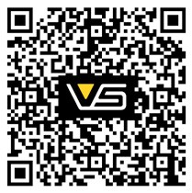

Product pictures by Vossloh-Schwabe in adequate resolution are available upon request for member of the press.

Press Contact / Journalist-Request:

Barbara Lenz . Vossloh-Schwabe (VS) Marketing / Communications
Fon +49 (0)7181 8002-252 . Fax +49 (0)7181 8002-122 .
Cell +49 (0)152 56714 212
Mail: barbara.lenz@vsu.vossloh-schwabe.com www.vossloh-schwabe.com

DATA AND
FACTS

Business activity
  - Full-range provider of energy-efficient LED and light management systems
  - Development, production and sale of lighting technology components

Workforce
Total employees: 1,167 (as at: February 2016)

Locations Urbach Kamp-Lintfort Lüdenscheid Oschatz
Svilajnac / Serbien Sarsina / Italien

Subsidiaries
wordwide about 20 Subsidiaries

Central warehouses Ettlingen (bei Karlsruhe) Singapur

VS and the Environment
Almost all VS locations are supplied with energy generated only from renewable sources. Almost all production sites are certified in accordance with ISO 14001:2004 and are thus committed to pursuing a continuous improvement process with regard to their corporate environmental policies

Turnover
214 million per annum (as at fiscal 2014)

Board
Setsuo Mizusawa, CEO Klaus Breisch
Hermann Kratschus

2. DATA AND FACTS

Headquartered in Germany, Vossloh-Schwabe has been a member of the global Panasonic group since 2002 within the lighting sector and counts as one of the technology leaders. Vossloh-Schwabe’s range of products and services covers the entire field of classic lighting technologies:

LED modules are available in COB and SMD technology, in round, square or linear designs and for nearly all fields of application – highly efficient, with a service life of up to 50,000 hours and, for the LUGA series, a minimal decrease in luminous flux of L90/B10. Add to that matching optical systems and lenses made of PMMA or silicone as well as linear systems of up to 2 metres in length, which are manufactured in one piece in a special production process.

As a perfect complement to the modules, LED drivers are also available in dimmable (1-10 V and DALI) as well as non-dimmable versions for LED constant current modules (up to 3,200 mA) with freely configurable output currents and for LED constant voltage modules (12 V or 24 V). These drivers are characterised by high efficiency, a long service life as well as overvoltage, overheating and no-load resistance.

The LiCS Indoor and LiCS Outdoor light management systems guarantee maximum energy and cost savings as well as additional convenience and safety.

At the same time, VS continue to cover the entire range of conventional lighting technology with electronic and magnetic ballasts, ignitors and lampholders for practically all commonly available light sources.

One of Vossloh-Schwabe’s particular strengths lies in
providing customised solutions, from individual LEDs to complete LED modules with special spectral distributions or the development and production of application-specific optics.

In this context, a systemic approach is decisive for creating turnkey solutions made up of perfectly matched individual components.

SMART
LIGHTING

Intelligent light – At any time

An office floor lamp that gets brighter as soon as someone comes near or an exhibition space in a museum in which, upon being entered, a video starts and a matching light ambience is created as if by magic – smart lighting delivers the right kind of light when it‘s needed. The result is a level of convenience that facilitates creativity and is efficient at the same time. Our smart products make lighting more intelligent and also open up new potential.

For instance Dim ONE. In its SMART version, the stylish dimmer comes with numerous light scenarios and is super easy to operate using a tablet or smartphone via Bluetooth. And luminaire manufacturers can integrate or retrofit this lighting smartness
with our latest wireless controllers of the XSW series.

Outdoor lighting is also getting an intelligence boost – with customers receiving a solution that suits the requirements of the respective task at hand. From intelligent island solutions to networked light management, various product suites are available, all of which can be freely combined.

4. LIGHT & BUILDING TRADE FAIR

VS Innovations at the Light + Building

Presentation of new VS products at the world’s leading lighting fair in Frankfurt

The Light+Building in Frankfurt counts as a leading global fair. This year’s top topic is smart lighting, which involves providing the right dosage of lighting at the right time and in the right place.
Vossloh-Schwabe – a company with a long lighting tradition and one of the renowned exhibitors at the Light+Building – will be presenting numerous product innovations at the fair. For instance: lighting solutions that team greater versatility with cost-effectiveness and more convenience. VS provides smart lighting solutions for offices, shops and supermarkets as well as production facilities and the entire outdoor lighting segment. As a full-range provider of
lighting solutions, VS produces energy-efficient LEDs and turnkey light management systems.

In this context, a particular focus is on developing and manufactur- ing highly efficient optical systems. PMMA, PC or silicone is used to create precise optics for practically any field of application –
producible in a customer-specific manner in continuous lengths of up to 2 metres.

A second area of focus is human-centric lighting, for which Vossloh- Schwabe also provides a range of outstanding solutions. Our Tune- able White Linear with 2-Chip-LEDs and infinitely adjustable spectral distribution is just one example.

www.light-building.de

NEW
PRODUCTS
SMART LIGHTING

Control Systems

All devices suitable for direct connection to 220–240 V mains voltage

Dim ONE
Dimmer with style
  - 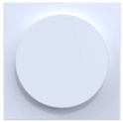Elegant dimmer, suitable for halogen and LED
  - Adjustable minimum light level to counter flickering; phase-cutting trailing-edge dimmer
  - Output range: 3 to 450 W

Dim ONE Bluetooth SMART
Intelligent dimmer system
  - Variable light scenarios (e.g. Zone, Scene, Timer, Away, Holiday)
  - Suitable for halogen and LED, control via Bluetooth
  - Adjustable minimum light level to counter flickering; phase-cutting trailing-edge dimmer
  - Output range: 3 to 450 W

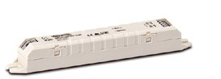Light Controller XSW-E6
Wireless multi-talent for luminaire integration
  - Suitable for standalone, network and mesh network operation
  - Integration in IP/DALI networks for up to 6 DALI luminaires or sensors

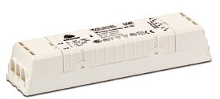Light Controller XSW-E64
Wireless multi-talent for network integration
  - EnOcean DALI router (broadcast) without the need for additional software
  - 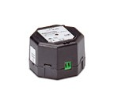Suitable for network operation with easy integration into IP/DALI networks

XSW Router
EnOcean DALI control made easy
  - EnOcean DALI router (broadcast)
  - Integrated DALI current supply (20 mA)
  - No additional software needed

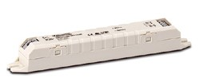Light Controller XSW Smart
All-in-One EnOcean DALI Controller
  - EnOcean DALI control
  - Suitable for up to 15 DALI luminaires, incl. sensors
  - Simple software-based configuration of individual luminaires and groups
  - Suitable for connection to EnOcean daylight and motion sensors

MediaServer and LiCS Outdoor

VS MediaServer
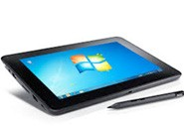Synchronising a cohesive light ambience with music or videos is as easy as child's play with our new MediaServer.

Flexible DALI/DMX control for an ambience of harmonised light, audio and video
  - Light, audio and video synchronisation for shops, museums or façades
  - Super-easy browser-based configuration
  - Simple creation of light scenarios with audio-visual integration
  - Open and flexible interfaces (DMX, DALI, IP network, EnOcean, audio)
  - Combinable with Panasonic Space Player

LiCS Outdoor
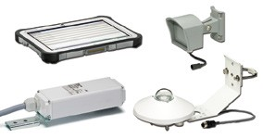Intelligent, modular light management
  - Smart Night – configurable controller with two lighting profiles as well as detection of changing day-night cycle in the summer and winter
  - Flex Night – controller configurable in groups via the supply line
  - Managed Night – integrated control solution with an online communications centre

Linear LED-Modules

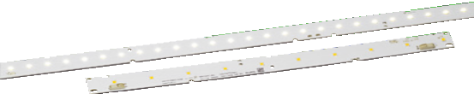LED Line SMD L14/28/56 W2
The standard for office lighting, ZHAGA-compliant
  - Standard and high-brightness with on-board push-in terminals
  - Luminous flux from 150 lm to 4600 lm
• Colour temp.: 3000 K, 4000 K, 5000K, 6500 K, CRI ≥ 80
  - Efficiency: up to 156 lm/W

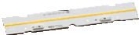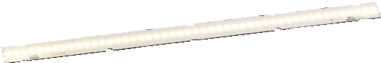LUGA Line RX
Linear COB modules for creating homogeneous light ribbons
  - Luminous flux from 700 lm to 2200 lm
• Colour temp.: e.g. 2700 K, 3000 K, 4000 K, 6500 K
  - Service life: 50,000 h (L90/B10)
  - Efficiency: up to 148 lm/W

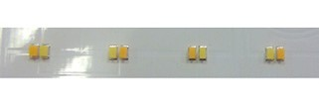Tuneable White Linear
With adjustable light temperatures for increasing wellbeing
  - Two-channel system
  - Colour temperature blends from 2700 K to 6000 K, CRI > 80
  - Colour tolerance: 4 SDCM
  - Efficiency: > 100 lm/W

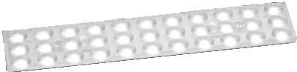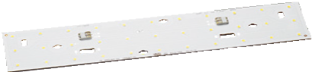LEDLine SMD Kit 1R and 3R
Highly adjustable 1- and 3-row built-in LED modules
  - Flexible light distribution thanks to various optics attachments
  - Output ratings: standard and high-brightness
  - ZHAGA-compliant fixing dimensions
  - Luminous flux: up to 3000 lm
• Colour temp.: 3000 K, 4000 K, 5000 K, 6500 K, CRI ≥ 80
  - Service life: 50,000 h (L80/B10)
  - Efficiency: up to 174 lm/W

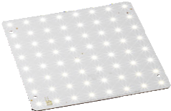LED Light Panels SMD
Efficient and affordable surface lighting
  - Two module dimensions: 250 x 250 mm, 270 x 270 mm
  - Luminous flux: up to 2600 lm
• Colour temp.: 3000 K, 4000 K, 5000 K, 6500 K CRI ≥ 80
  - Service life: 50,000 h (L80/B10)
  - Efficiency: up to 174 lm/W

Matching Driver and Control Systems

PrimeLine
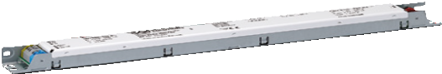Programmable intelligent drivers for maximum versatility
  - Suitable for Tuneable White Linear
  - Output current programmable in 1 mA steps
  - Suitable for use with DC* and dimmable via DALI, PUSH
  - Current range: 350 – 700 mA at 42 – 84 W*
  - Service life: up to 100,000 h

ComfortLine
Convenient drivers with selectable current
  - 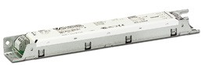Current range selectable via resistor (LEDset standard), output terminal or dipswitch*
  - SELV as well as non-SELV solutions
  - Suitable for use with DC*, dimmable via DALI, PUSH, 1–10 V*
  - Current range: 60 – 700 mA* at 15 – 140 W*
  - Service life: up to 100,000 h

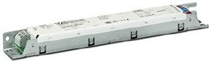EasyLine
Cost-efficient driver with a focus on core functions
  - Current range selectable via the output terminal*
  - SELV as well as non-SELV solutions
  - Current range: 150 – 700 mA* at 6 – 60 W*
  - Service life: up to 50,000 h

Dim ONE Bluetooth SMART
Intelligent dimmer system
  - Variable light scenarios (e.g. Zone, Scene, Timer, Away, Holiday)
  - Suitable for halogen and LEDs, control via Bluetooth
  - Adjustable minimum light level to counter flickering; phase-cutting trailing-edge dimmer
  - 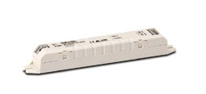Output range: 3 to 450 W

Light Controller XSW-E6
Wireless multi-talent for luminaire integration
  - Suitable for standalone, network and mesh network operation
  - Integration in IP/DALI networks for up to 6 DALI luminaires or sensors

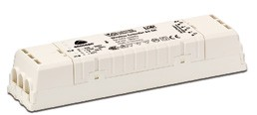Light Controller XSW-E64
Wireless multi-talent for network integration
  - EnOcean DALI router (broadcast) without the need for additional software
  - Suitable for network operation with easy integration into IP/DALI networks
*model-dependent

LED-Modules for Street Lighting

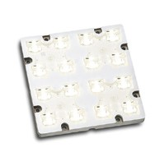LED Light IP67 Gen. 2
Encapsulated LED module with a high degree of protection
  - Built-in module with IP and IK degrees of protection (IP67, IP69, IK08)
  - Optics material: silicone
  - Luminous flux: 2200 lm to 7900 lm
  - Colour temperatures: 3000 K, 4000 K, 5000 K, CRI ≥ 65,
≥ 70, ≥ 80
  - Colour tolerance: 5 SDCM
• Service life: > 60.000 h (L80/B10)
  - Efficiency: up to 154 lm/W
  - Surge protection: 4 kV
  - 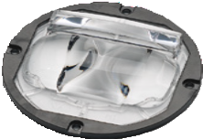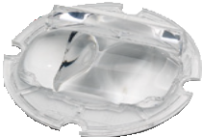Optimum installation ratio: 4.5:1 (M class optics)

COB Silicone Optics M-Class M1 and Area
Optimum light distribution with integrated protection factor
  - Excellent translucency
  - Suitable for COB modules with an LES of up to 23 mm
  - Degrees of protection: IP65, IK08
  - Optical efficiency: up to 95%
  - High temperature stability (up to 150 °C)

Matching Driver and Control Systems

PrimeLine
Programmable intelligent drivers for maximum versatility
  - Programmable functions (e.g. MidNight)*
  - 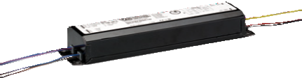Output current programmable in 1 mA steps (DALI) via dipswitch*
  - Integrated power reduction*
  - Dimmable via 1–10 V
  - Very low output ripple and flicker
  - Protection classes: IP65, IP20*
  - Current range: 350 to 1400 mA* at 75 to 150 W*
  - Service life: up to 100,000 h

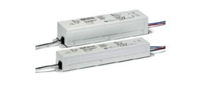ComfortLine
Convenient drivers
  - Integrated power reduction
  - Dimmable via 1–10 V*
  - Protection classes: IP67, IP65, IP20*
  - Current range: 350 to 1050 mA* at 40 to 150 W*
  - Service life: up to 100,000 h

LiCS Outdoor
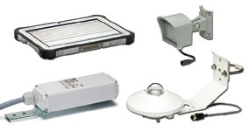Intelligent, modular light management
  - Smart Night – configurable controller with two lighting profiles as well as detection of changing day-night cycle in the summer and winter
  - Flex Night – controller configurable in groups via the supply line
  - Managed Night – integrated control solution with an online communications centre

*model-dependent

LED-Modules for Industrial Lighting

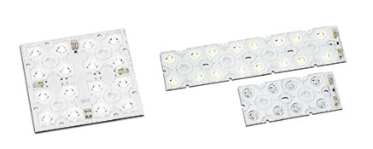LED Modules IP20
Highly efficient modular solution
  - LED modules with 4, 8, 16, 32 and 64 high-power LEDs
  - Luminous flux: 500 lm to 31500 lm
  - Colour temperatures: 3000 K, 4000 K, 5000 K
  - Colour rendering: CRI ≥ 65, ≥ 70, ≥ 80
  - Colour tolerance: 5 SDCM
• Service life: > 60,000 h (L80/B10)
  - Efficiency: up to 154 lm/W
  - Surge protection: 4 kV

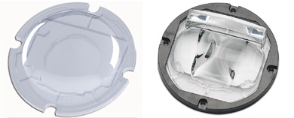COB Silicone Optics SYM II
Optimum light distribution with integrated protection factor
  - Excellent translucency
  - Suitable for COB modules with an LES of up to 23 mm
  - Protection classes: IP65, IK08
  - Optical efficiency: up to 95 %

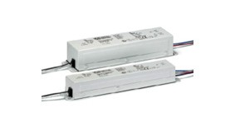Matching Driver and Control Systems ComfortLine
Convenient drivers with selectable current
  - Current range selectable via dipswitch*
  - SELV as well as non-SELV solutions
  - Very low output ripple and flicker
  - Suitable for use with DC*
  - Dimmable via DALI, PUSH and 1–10 V*
  - Current range: 350 to 1400 mA* at 20 to 126 W*
  - Service life: up to 100,000 h

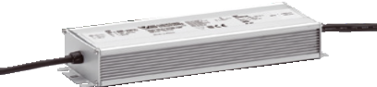EasyLine
Cost-efficient driver with a focus on core functions
  - Protection class: IP67
  - Low output ripple and flicker
  - Current range: 700 to 3200 mA* at 50 to 230 W*
  - Service life: up to 50.000 h

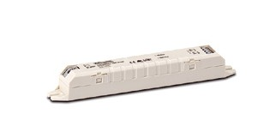Light Controller XSW Smart
All-in-One EnOcean DALI Controller
  - EnOcean DALI control
  - Suitable for up to 10 DALI luminaires, incl. sensors
  - Simple software-based configuration of individual luminaires and groups
  - Suitable for connection to EnOcean daylight and motion sensors
  - Direct connection to 220–240 V mains voltage

*model-dependent

LED-Modules for Shop Lighting

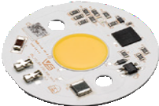ReadyLine COB
Innovative LED modules for compact spots for direct connection to 220–240 V mains voltage
  - Colour temperatures: 2700 K, 3000 K, 3500 K, 4000 K, 5000 K
  - Service life: 50,000 h (L70/B50)
  - Efficiency: up to 95 lm/W

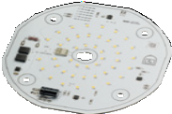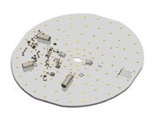Readyline DL 160 / Readyline DL 250 / Readyline DL 250 EM (Emergency Lighting) Highly efficient built-in LED modules for direct connection to 220–240 V mains voltage
  - Colour temperatures: 3000 K, 4000 K, 5000 K, CRI 80
  - Service life: 55,000 h (L70/B50)
  - 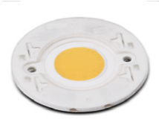Efficiency: up to 110 lm/W

LUGA Shop Gen 5
The latest generation of retail lighting perfection
  - Luminous flux: 500 lm to 16,000 lm
  - Standard colour temperatures: 2700 K to 4000 K
  - Special light temperatures for fashion and food
  - Service life: 50,000 h (L90/B10)
  - Efficiency: up to 170 lm/W

Matching Driver and Control Systems

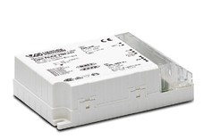PrimeLine
Programmable intelligent drivers for maximum versatility
  - Output current programmable in 1 mA steps
  - Very low output ripple and flicker
  - Suitable for use with DC and dimmable via DALI, PUSH
  - Current range: 350 – 700 mA at 24 W – 37 W*
  - Service life: up to 100,000 h

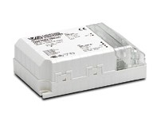ComfortLine
Convenient drivers
  - Very low output ripple and flicker
  - Suitable for use with DC*, dimmable via DALI, PUSH, 1–10 V*
  - Current range: 350 – 1050 mA* at 24 – 60 W*
  - Service life: up to 100,000 h

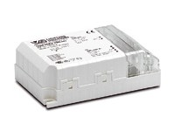EasyLine
Cost-efficient drivers with a focus on core functions
  - Current range selectable via the output terminal*
  - SELV
  - Current range: 250 – 1050 mA* at 10 – 45 W*
  - Service life: up to 50,000 h

Dim ONE Bluetooth SMART
Intelligent dimmer system
  - Variable light scenarios (e.g. Zone, Scene, Timer, Away, Holiday)
  - Suitable for halogen and LEDs, control via Bluetooth
  - Adjustable minimum light level to counter flickering; phase-cutting trailing-edge dimmer
  - Output range: 3 to 450 W

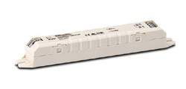Light Controller XSW-E6
Wireless multi-talent for luminaire integration
  - Suitable for standalone, network and mesh network operation
  - Integration in IP/DALI networks for up to 6 DALI luminaires or sensors

Light Controller XSW-E64
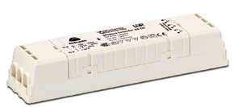Wireless multi-talent for network integration
  - EnOcean DALI router (broadcast) without the need for additional software
  - Suitable for network operation with easy integration into IP/ DALI networks
*model-dependent

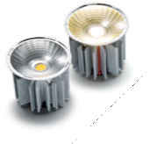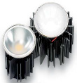LED-Modules for Residential Lighting ActiveLine with extra narrow beam angle
Highly efficient MR16 halogen replacement
  - New extra narrow beam angle: 10°
  - Architectural and retail lighting

ActiveLine HALO
The MR16 halogen replacement
  - Same behaviour of halogen lamps: dim down colour temperature shift from 3000 K to 2000 K
  - Colour rendering: CRI 90

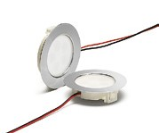FlatLine
Cost effective LEDSpot in a flat design
  - With a constant current driver (700 mA) or a constant voltage driver (12 V)
  - Fully equipped with optics, leads and frame
  - Beam angle: 40°
  - For cut-out: Ø 56 mm
  - Colour temperatures: 3000 K, 4000 K

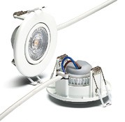DecoLED 7W
Elegant LEDSpot
  - Fully equipped with optics, heat sink, leads and metal frame for direct connection to 230 V mains voltage
  - Swivel-mounted luminaire head
  - Beam angle: 38°
  - Power consumption: 7 W
  - Efficiency: up to 80 lm/W

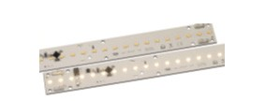ReadyLine L28/8.7 W
Built-in LED module for direct connection to 230 V mains voltage
  - Aluminium PCB for optimum thermal management
  - Integrated push-in connector: 0.2 – 0.75 mm² (24 – 18AWG)
  - Module dimensions (L x W): 280 mm x 30 mm
  - Luminous flux: 780 lm
  - Colour temperature: 3000 K, 4000 K

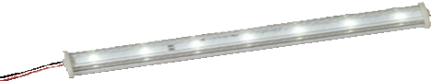LED module Cryo
Slim-line LED module with a customisable length
  - 24 V system
  - Modular system with segments of 200 mm length
  - Luminous flux: 250 lm (600 mm), 500 lm (1,200 mm)
  - Power consumption: 2.15 W/4.3 W

Matching Driver and Control Systems ComfortLine
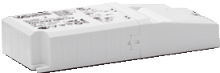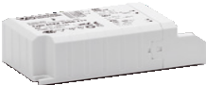Convenient drivers
  - Very low output ripple and flicker
  - Suitable for use with DC*
  - Dimmable with phase-cutting leading- and trailing-edge dimmer*
  - Current range: 350 – 1050 mA* at 8 – 40 W*
  - 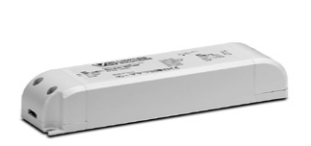Service life: up to 100,000 h

EasyLine
Cost-efficient drivers with a focus on core functions
• Current range: 150 – 1,050 mA* at 5.6 – 60 W*
  - Service life: up to 50,000 h

Dim ONE
The stylish dimmer
  - Elegant dimmer with state-of-the-art technology
  - Suitable for halogen and LEDs
  - Adjustable minimum light level to counter flickering
  - Dimming: phase-cutting trailing-edge
  - Output range: 3 to 450 W

Dim ONE Bluetooth SMART
The intelligent dimmer system
  - Variable light scenarios
(e.g. Zone, Scene, Timer, Away, Holiday)
  - Suitable for halogen and LEDs, control via Bluetooth
  - Adjustable minimum light level to counter flickering; phase-cutting trailing-edge dimmer
  - Output range: 3 to 450 W

*model-dependent

HUMAN CENTRIC LIGHTING

LED-Modules for Human Centric Lighting

Our human-centric lighting product with 20 highly efficient COB LED chips permits infinite adjustment of light temperatures as well as targeted modification of biologically effective spectrums.
In workspaces, this means light can be adjusted to suit the biorhythms of the employees. Nearly the same effect can be achieved in the fields of education and medicine.

The built-in human-centric LED module can thus contribute to improving health and cognitive performance.

Typical Fields of Application:
  - Residential care and nursing homes
  - Private homes, hotels
  - Kindergartens, schools, universities
  - Offices and industrial workspaces

Built-in LED Module for Human-centric Lighting
Optimised and efficient COB technology
  - 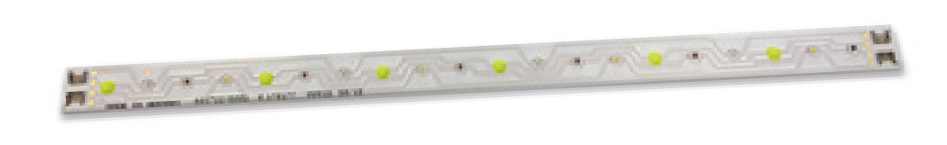20 highly efficient LED chips
  - 4 light channels
  - Ceramic PCB
  - On-board push-in terminal
  - Customer-specific solutions

HUMAN CENTRIC LIGHTING

Matching Driver and Control Systems

A Perfect Match: Our PrimeLine Driver
Programmable intelligence for maximum versatility
  - 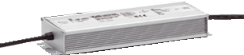4-channel output– each independently dimmable, DALI
  - Suitable for DC operation
  - Output: max. 188 W
  - Output current: selectable between 350 and 700 mA via resistor
  - Very narrow output current tolerance
  - Practically free of inrush current
  - Very low output ripple and flickering
  - Degree of protection: IP65
  - Service life: up to 100,000 h

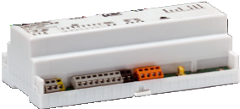Light Controller IP
Network-capable DALI light control (2 DALI lines), ideal for new projects and retrofits
  - Energy savings thanks to daylight- and occupancy-based control
  - Touch4Light via tablet (browser-based)
  - EnOcean wireless operation

Light Controller XSW-E6
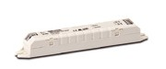Wireless multi-talent for luminaire integration
  - Suitable for standalone, network and mesh network operation
  - Integration in IP/DALI networks for up to 6 DALI luminaires or sensors

GREENHOUSES &
ANIMAL LIGHTING

LED-Modules for Greenhouses & Animal Lighting

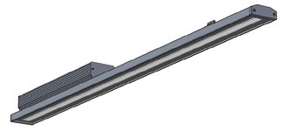LED System Solution for Greenhouses and Livestock Highly efficient LED system in an elegant aluminium profile with a driver-installation-box
  - Optimised COB technology for plants and livestock
  - 4 light channels, individually addressable via DALI
  - Optimised light spectrum
  - Protection class I
  - Degree of protection: IP65

Built-in LED module for Greenhouses and Animal
Optimised and efficient COB technology
  - 20 highly efficient LED chips
• 4 light channels
  - Ceramic PCB
  - On-board push-in terminal
  - Customer-specific solutions

GREENHOUSES & ANIMAL LIGHTING

Matching Driver and Control Systems

A Perfect Match: Our PrimeLine Driver
Programmable intelligence for maximum versatility
  - 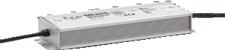4-channel output – each independently dimmable, DALI
  - Suitable for DC operation
  - Output: max. 188 W
  - Output current: selectable between 350 and 700 mA via resistor
  - Very narrow output current tolerance
  - Practically free of inrush current
  - Very low output ripple and flickering
  - Degree of protection: IP65
  - Service life: up to 100,000 h

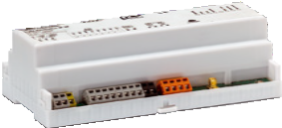Light Controller IP
Network-capable DALI light control (2 DALI lines), ideal for new projects and retrofits
  - Energy savings thanks to daylight- and occupancy-based control
  - Touch4Light via tablet (browser-based)
  - EnOcean wireless operation

Light Controller XSW-E64
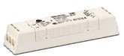Wireless multi-talent for network integration
  - EnOcean DALI router (broadcast) without the need for additional software
  - Suitable for network operation with easy integration into IP/DALI networks

Whenever an electric light goes on around the world, Vossloh-Schwabe is likely to have made a key contribu- tion to ensuring that everything works at the flick of a switch.

Headquartered in Germany, Vossloh- Schwabe has been a member of the global Panasonic group since 2002 and counts as a technology leader within the lighting sector. Top-quality, high-performance products form the basis of the company’s success.

Vossloh-Schwabe’s extensive product portfolio covers all lighting components: LED systems with matching control gear units, highly efficient optical systems, state-of-the- art control systems (LiCS) as well as
electronic and magnetic ballasts and lampholders.

The company's future is Smart Lighting.

Vossloh-Schwabe Deutschland GmbH

Hohe Steinert 8 · 58509 Lüdenscheid · Germany
Phone +49 (0) 23 51/10 10 · Fax +49 (0) 23 51/10 12 17

www.vossloh-schwabe.com

All rights reserved © Vossloh-Schwabe Technical changes are subject to change without notice
Press Kit L+B EN 03/2016

